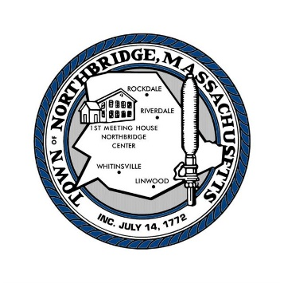 | TOWN OF NORTHBRIDGE  OFFICE OF THE TOWN CLERK  7 MAIN STREET  WHITINSVILLE, MASSACHUSETTS, 01588  Phone: 508-234-2001 | Linda B. Zywien, CMC  Town Clerk  lzywien@northbridgemass.org  Laura Medeiros  Assistant Town Clerk  lmedeiros@northbridgemass.org

IT’S TIME TO GET MY DOG LICENSE!!

- On Line: Access our website (northbridgemass.org); click on Departments, then Town Clerk. A quick link on the Clerk’s page will take you to our online payment center. This option can be used to license or relicense your dog, ONLY if you know that the Clerk has the current rabies certificate, as well as proper spay/neuter info, for your dog.
- OR, complete this form and return it

- In Person: at the Town Clerk’s office. Be sure to bring a current rabies vaccination certificate.

- By Mail: Along with the form, we need a current rabies vaccination certificate and proof of spaying/neutering. Be sure to enclose a check made payable to the Town of Northbridge for the proper fee with your request.
FEES: Neutered/Spayed dogs $6.00 Male/Female (Unaltered) dogs $10.00

*A $10.00 late fee (per family) will be applied for licenses obtained after May 31, 2024. *Late fee does not apply to new dogs.

-----------------------------------------------------------------------------------

DOG LICENSE BY MAIL

Owner Name:___________________________________________________________________________
Address:_________________________________________ Tel: ________________________________ Email: _____________________________________ Veterinarian:______________________________

Dog Information: _________________ ________________ _______________ _____________
Name Breed Age/Date of Birth Color

Male___ Neutered___ Female___ Spayed___

Dog Information: _______________ ________________ _______________ ______________
Name Breed Age/Date of Birth Color

Male___ Neutered___ Female___ Spayed___

Dog Information: _________________ _________________ _______________ _______________
Name Breed Age/Date of Birth Color

Male___ Neutered___ Female___ Spayed___

